Hemlock Survey Reference Sheet

Identifying an Eastern Hemlock

Hemlocks have wide, short needles that grow parallel to the forest floor. There are characteristically two white lines on the under surface of the needles. The bark is thick and scaled, and usually a brown to cinnamon color.

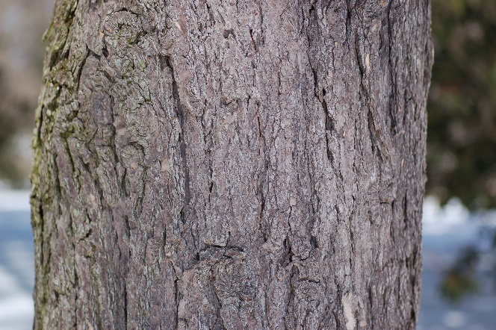
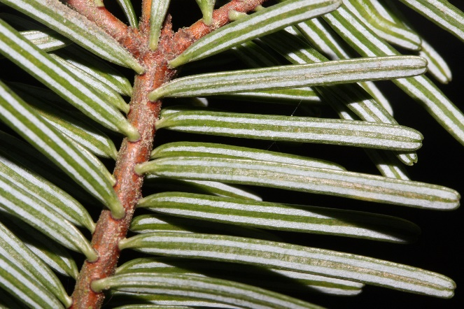
Eastern Hemlock Bark Eastern Hemlock Needles

Identifying Hemlock Woolly Adelgid

Hemlock woolly adelgid (HWA) is easiest to identify by the white fluffy masses they spin around themselves throughout the year. These will almost always occur on the underside of the needles, on the twig next to the base of the needle. In extremely high populations, these HWA egg sacs will sometimes be found on the twig above the needles, but it is rare.

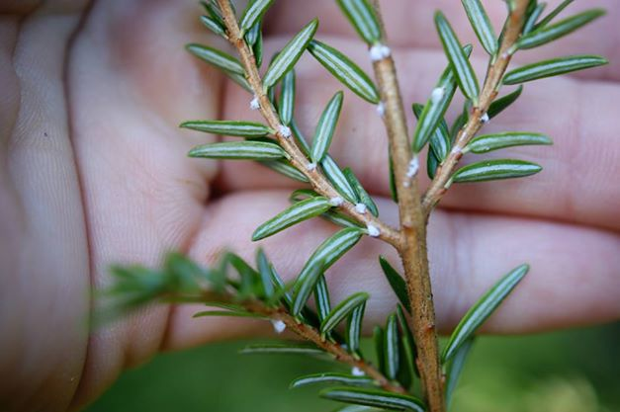
Hemlock Woolly Adelgid

Data Entry

You can find the reporting forms on the Catskill Center website, www.catskillcenter.org. Please download and fill them out electronically. You can then email the completed form to dsnider@catskillcenter.org.
Data collection methods

Record the hemlock stand location, surveyors, and date for the site to be surveyed.

If possible, for each plot point within the stand that you survey, take a GPS point and record it under the “Plot GPS” the column.

Establish a center point of data collection that is as close to the GPS plot point as possible.

Choose the 3 closest hemlocks to the data collection center point that have foliage accessible to you.

On each hemlock, look at the first meter of one foliated branch, looking for white woolly masses distinct to hemlock woolly adelgid egg sacs. If any adelgid is found, count the amount of adelgid egg sacs on only the first 5 cm of the branch. If no adelgid is found, record as 0 in the “Eggs” column. If 1- 19 adelgid are found, mark as 1. 20-39 adelgid are marked as 2. 40+ adelgid are marked as 3.

On the same branch, look for presence of the hemlock’s new buds. These will appear as brighter, light green needles growing on the very tips of the branches. Record the number of occurrences of new buds within the first 5 cm of branch.

Using the reference, record the transparency for the tree. Transparency is a measure of how much sunlight filters through the canopy of the tree. To find the transparency, look up at the canopy while standing near the trunk of the hemlock and draw a mental circle around the extent of the hemlock’s drip line. To the nearest 5%, approximate how much light filters through the canopy of the hemlock.

Using the other reference, record the Live Crown Ratio (LCR) for the tree. LCR is a measure of how much of the trunk height has foliated branches. This is easier to measure from at least one trunk’s height in distance from the tree. Approximate, to the nearest 5%, the percentage of the trunk of the hemlock that contains branches with live needles rather than bare branches or no branches.

Repeat for all three selected hemlocks.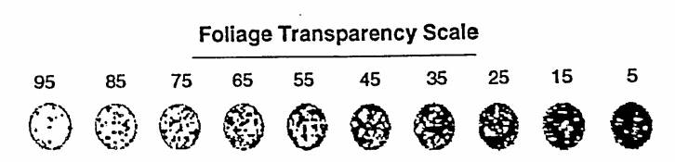
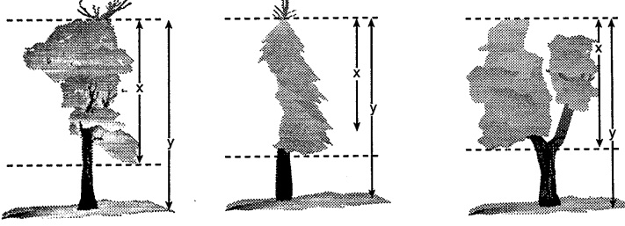
Live Crown Ratio Reference

